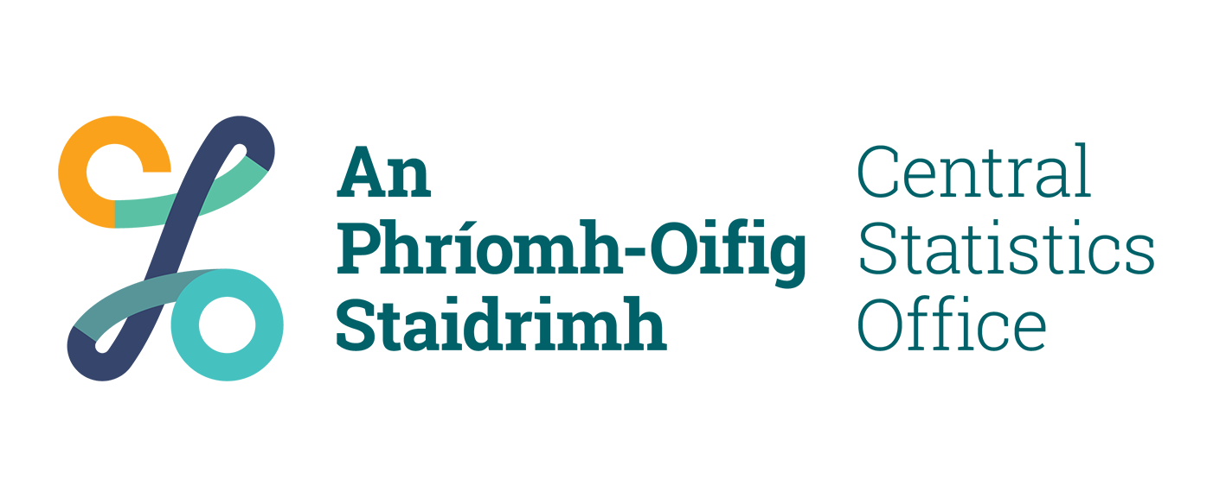 | Freedom of Information Act 2014  CSO Application Form

- Applicant details (please use BLOCK capitals)

First Name |  | Title (Mr./Ms./Mrs./Miss/Other)
Surname

Address

Phone - Work |  | Home |  | Fax

- Are you making this request for an Organisation/Company ( ) ?

If Yes, state:

- Organisation/Company name

- Position you hold in it

- Details of Request

In accordance with Section 12 of the Freedom of Information Act 2014

(a) I request access to records containing ():

Personal information relating to myself Non-personal information
(you may be asked to provide proof of your identity)

(b) relating to the following matter (describe in as much detail as possible):

(If insufficient space please attach a separate sheet containing additional information)

- Form of Access Required (please tick in appropriate box)

photocopy of the record inspection of the record
other form of access: specify ⇒

Signature |  | Date

Send the completed application form to | ⇒ Freedom of Information Officer  Central Statistics Office  Skehard Road  Cork  E-mail: foi@cso.ie
Phone queries to Extension 5385 at:
(021) 4535000 or (01) 4984000

